Name:
Distance and Displacement Practice
Distance = "how much ground an object has covered" during its motion. The total distance you had to cover to get somewhere.
Displacement=the straight line distance from the starting point to the finishing point.
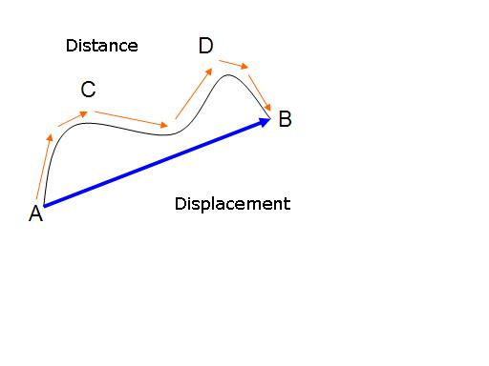
In the diagram above the movement from A to C to D to B is the distance.
The distance between A and B is the Displacement.
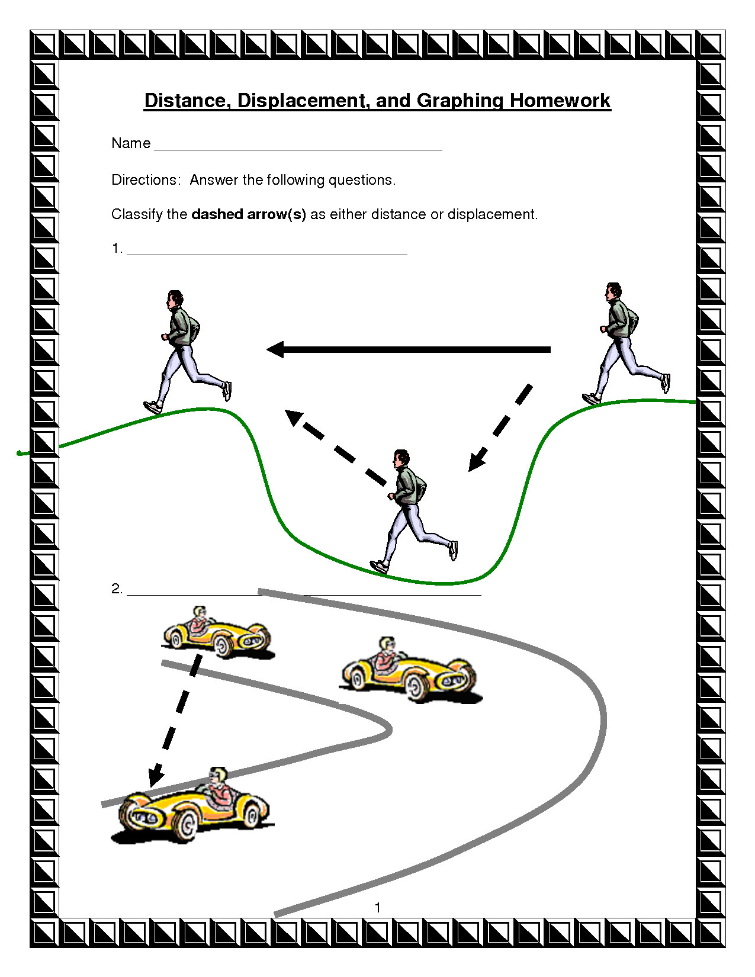

Calculate the distance and displacement in each of the following situations

- Rochelle runs 2km south, then turns around and runs 3km north.
What distance did she run?
What is her displacement?

- Paul runs exactly 2 laps around a 400 meter track.
What distance did he run?
What is his displacement?

- Thalia spins around 5 times without moving any direction.
What distance did she move?
What is her displacement?

- Tom walks two miles north from his door to the park, then returns home to his door.
What distance did he move?
What is his displacement?

- Kiri ran 8 blocks north, and then 2 blocks south back toward her starting point.
What distance did she move?
What is her displacement?

- Mohammad dove in at the south end of the swimming pool then swam 3 complete laps of the 50 meter pool. (1 lap is one length of the pool.)
What distance did he swim?
What is his displacement?

- Mihi walks east for 3 km, stops for a break, and then runs the same direction for 4 km before she stops.
What distance did she move?
What is her displacement?

- Cameron rides his bicycle 20 km north, turns around, and then rides the bicycle 15 km back toward his starting point.
What distance did he move?
What is his displacement?

